Beauty and Joy of Computing Unit 8 Assessment
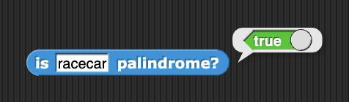
Write a recursive program in Snap!. Your recursive function should include the following:
- A base case for the lowest level that stops the recursion from going on forever.
- A recursive case that calls the block itself at lower levels until it reaches the base case.

Your program should have a clearly defined purpose and cannot be a duplicate of one you already wrote while completing the labs in Unit 7 or Unit 8.

Some possible problems to solve include:
- Write a program to calculate the Fibonacci sequence up to the n^{th} number (where n is the input into the program). The Fibonacci sequence is a series of numbers where each number is the sum of the two preceding ones, usually starting with 0 and 1. The sequence goes 0, 1, 1, 2, 3, 5, 8, 13, and so forth.
- Write a program to check if a word is a palindrome. A word that is a palindrome reads the same forward and backward. For example, "madam" or "racecar" are palindromes.
- Write a program to reverse the characters in a string. For example, “goodnight” will become “thgindoog”.
- Write a program to compute x^{n} (x raised to the power n) recursively.

